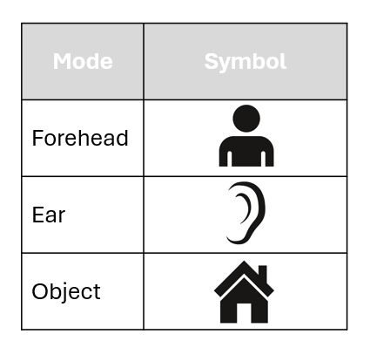
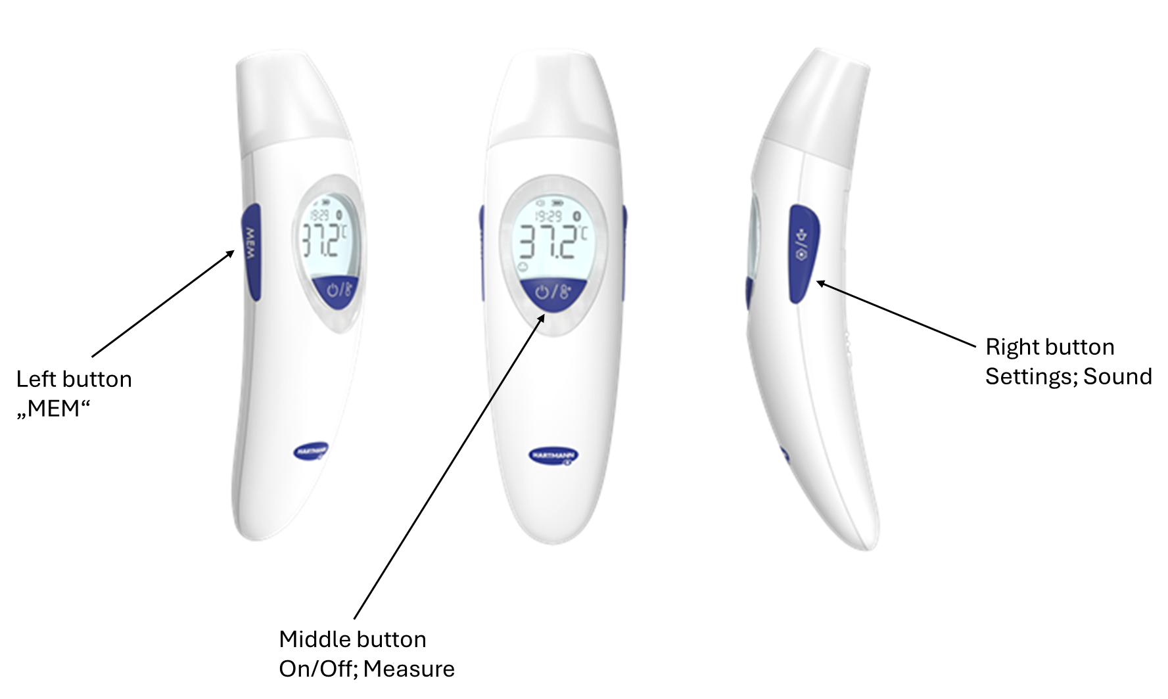
Low battery warning:
- If the battery load is < 2.70 V, the low battery sign blinks.
- If the battery load is < 2.60 V, the outer frame of battery symbol is displayed with . With that, no backlight is possible and no measurement can be taken. The device turns off automatically after 30s.
End of measurement:
Object mode – The end of a measurement is signalized through sound/vibration (“-“). The backlight is always green.
Forehead mode/ ear mode – The end of a measurement is signalized through sound/vibration (see table below).
Together with the (alarm) signal/vibration, a colored backlight turns on (green, orange, red). After 15 s, the colored backlight turns off again. For auditive/haptic feedback, the following beep/vibration pattern are implemented:

Temperature [°C] |  | Temperature  [°F] | Beep/Vibration pattern | Backlight color | Smiley indicator | Display
 | 0 – 3 months
34.0 ≤ T ≤ 37.4 |  | 93.2 ≤ T ≤ 99.4 | - | Green
37.4 < T ≤ 43.0 |  | 99.4 < T ≤ 109.4 | - · · · | Red
T < 34.0 |  | T < 93.2 | · · · · | Green |  | Lo
T > 43.0 |  | T > 109.4 | - · · · | Red |  | Hi
 | 3 – 36 months
34.0 ≤ T ≤ 37.6 |  | 93.2 ≤ T ≤ 99.6 | - | Green
37.6 < T ≤ 38.5 |  | 99.6 < T ≤ 101.3 | - | Orange
38.5 < T ≤ 43.0 |  | 101.3 < T ≤ 109.4 | - · · · | Red
T < 34.0 |  | T < 93.2 | · · · · | Green |  | Lo
T > 43.0 |  | T > 109.4 | - · · · | Red |  | Hi
 | 36+ months
34.0 ≤ T ≤ 37.7 |  | 93.2 ≤ T ≤ 99.9 | - | Green
37.7 < T ≤ 39.4 |  | 99.9 < T ≤ 103.0 | - | Orange
39.4 < T ≤ 43.0 |  | 103.0 < T ≤ 109.4 | - · · · | Red
T < 34.0 |  | T < 93.2 | · · · · | Green |  | Lo
T > 43.0 |  | T > 109.4 | - · · · | Red |  | Hi
Note：“-” long beep (250ms)，“·” short beep (180ms)

Automatic switch-off: After 30 s with no button press, the device turns off automatically (without any vibration/sound feedback).

The key flow described below applies in every "age mode."

Button  (left = age/MEM, right = settings, middle = On/OFF) | Button press duration  (short: <1s, long: ca. 3s) | Device mode | Sound mode | Measurement mode | Cap mode | Description
☒left button  ☐middle button  ☐right button | ☒short  ☐long | ☐on  ☒off | ☒on  ☒off (Vibration) | ☐Forehead mode  ☐Object mode  ☐Ear mode | ☐cap on  ☐cap off | Memory mode
☐left button  ☒middle button  ☐right button | ☐short  ☒long | ☐on  ☐off  ☒on, memory mode | ☐on  ☒off (Vibration) | ☐Forehead mode  ☐Object mode  ☐Ear mode | ☐cap on  ☐cap off | Turn device off by long button press for 4s. Vibration feedback (“-“) signalizes successful turn-off.
☐left button  ☒middle button  ☐right button | ☐short  ☒long | ☐on  ☐off  ☒on, memory mode | ☒on  ☐off (Vibration) | ☐Forehead mode  ☐Object mode  ☐Ear mode | ☐cap on  ☐cap off | Turn device off by long button press for 4s. Sound feedback (“-“) signalizes successful turn-off.
☒left button  ☐middle button  ☐right button | ☒short  ☐long | ☒on  ☐off | ☐on  ☒off (Vibration) | ☒Forehead mode  ☐Object mode  ☒Ear mode | ☒cap on  ☒cap off | Device must vibrate if age function mode is changed by button press.
☒left button  ☐middle button  ☐right button | ☒short  ☐long | ☒on  ☐off | ☒on  ☐off (Vibration) | ☒Forehead mode  ☐Object mode  ☒Ear mode | ☒cap on  ☒cap off | Device must give signal if age function mode is changed by button press.
☒left button  ☐middle button  ☐right button | ☒short  ☐long | ☒on  ☐off | ☒on  ☒off (Vibration) | ☒Forehead mode  ☐Object mode  ☒Ear mode | ☒cap on  ☒cap off | Switching-time between age modes should be the same as in sound-on mode, to ensure consistency between sound-on/sound-off vibration modes.
☐left button  ☒middle button  ☐right button | ☒short  ☐long | ☐on  ☒off | ☐on  ☒off (Vibration) | ☐Forehead mode  ☐Object mode  ☐Ear mode | ☐cap on  ☐cap off | Turn device on without vibration feedback and when ready to measure “double vibration” as it is in sound mode but here with vibration.
☐left button  ☒middle button  ☐right button | ☒short  ☐long | ☐on  ☒off | ☒on  ☐off (Vibration) | ☐Forehead mode  ☐Object mode  ☐Ear mode | ☐cap on  ☐cap off | Turn device on without sound feedback and when ready to measure “double beep”.
☐left button  ☒middle button  ☐right button | ☐short  ☒long | ☒on  ☐off | ☐on  ☒off (Vibration) | ☒Forehead mode  ☒Object mode  ☒Ear mode | ☒cap on  ☒cap off | Turn device off by long button press for 4s. Vibration feedback (“-“) signalizes successful turn-off.
☐left button  ☒middle button  ☐right button | ☐short  ☒long | ☒on  ☐off | ☒on  ☐off (Vibration) | ☒Forehead mode  ☒Object mode  ☒Ear mode | ☒cap on  ☒cap off | Turn device off by long button press for 4s. Sound feedback (“-“) signalizes successful turn-off.
☐left button  ☒middle button  ☐right button | ☒short  ☐long | ☒on  ☐off | ☒on  ☐off (Vibration) | ☒Forehead mode  ☐Object mode  ☐Ear mode | ☒cap on  ☐cap off | Swipe-measurement starts (3s), rotating icon on display shows ongoing measurement, sound feedback + 15s backlight when measurement finished, show highest value.
☐left button  ☒middle button  ☐right button | ☒short  ☐long | ☒on  ☐off | ☐on  ☒off (Vibration) | ☒Forehead mode  ☐Object mode  ☐Ear mode | ☒cap on  ☐cap off | Swipe-measurment starts (3s), rotating icon on display shows ongoing measurement, vibration feedback + 15 s backlight when measurement finished, show highest value.
☐left button  ☒middle button  ☐right button | ☒short  ☐long | ☒on  ☐off | ☒on  ☐off (Vibration) | ☐Forehead mode  ☐Object mode  ☒Ear mode | ☐cap on  ☒cap off | Start measurement, sound feedback + 15 s backlight when measurement finished, after 5 seconds “ready-to-measure” double-beep feedback¹.
☐left button  ☒middle button  ☐right button | ☒short  ☐long | ☒on  ☐off | ☐on  ☒off (Vibration) | ☐Forehead mode  ☐Object mode  ☒Ear mode | ☐cap on  ☒cap off | Start measurement, vibration feedback + 15 s backlight when measurement finished.
☐left button  ☒middle button  ☐right button | ☒short  ☐long | ☒on  ☐off | ☒on  ☐off (Vibration) | ☐Forehead mode  ☒Object mode  ☐Ear mode | ☒cap on  ☐cap off | Start measurement (1s), sound feedback when measurement finished.
☐left button  ☒middle button  ☐right button | ☒short  ☐long | ☒on  ☐off | ☐on  ☒off (Vibration) | ☐Forehead mode  ☒Object mode  ☐Ear mode | ☒cap on  ☐cap off | Start measurement (1s), vibration feedback when measurement finished.
☐left button  ☐middle button  ☒right button | ☒short  ☐long | ☒on  ☐off | ☐on  ☐off (Vibration) | ☒Forehead mode  ☒Object mode  ☒Ear mode | ☒cap on  ☒cap off | Sound on/off, signalized by sound or vibration + icon in display if sound on.
☐left button  ☐middle button  ☒right button | ☐short  ☒long | ☒on  ☐off | ☒on  ☒off (Vibration) | ☒Forehead mode  ☒Object mode  ☐Ear mode | ☒cap on  ☐cap off | Switch between forehead and object mode.
☐left button  ☐middle button  ☒right button | ☐short  ☒long | ☒on  ☐off | ☒on  ☒off (Vibration) | ☐Forehead mode  ☐Object mode  ☒Ear mode | ☐cap on  ☒cap off | For ear mode, no action with this kind of button press.
☐left button  ☐middle button  ☒right button | ☐short  ☒long | ☐on  ☒off | ☐on  ☐off (Vibration) | ☐Forehead mode  ☐Object mode  ☐Ear mode | ☒cap on  ☒cap off | Show °C/°F menu.
☐left button  ☒middle button  ☐right button | ☒short  ☐long | ☐on  ☐off  ☒off °C/°F-mode | ☐on  ☐off (Vibration) | ☐Forehead mode  ☐Object mode  ☐Ear mode | ☒cap on  ☒cap off | Change between °C/°F.
☐left button  ☐middle button  ☒right button | ☒short  ☐long | ☐on  ☐off  ☒ off °C/°F-mode | ☐on  ☒off (Vibration) | ☐Forehead mode  ☐Object mode  ☐Ear mode | ☒cap on  ☒cap off | Select °C/°F, turn device off (with vibration feedback “-“).
☐left button  ☐middle button  ☒right button | ☒short  ☐long | ☐on  ☐off  ☒ off °C/°F-mode | ☒on  ☐off (Vibration) | ☐Forehead mode  ☐Object mode  ☐Ear mode | ☒cap on  ☒cap off | Select °C/°F, turn device off (with sound feedback “-“).
☐left button  ☐middle button  ☐right button | ☐short  ☐long | ☒on  ☐off | ☐on  ☒off (Vibration) | ☐Forehead mode ☐Object mode  ☐Ear mode | ☒cap on  ☒cap off | When cap put on/off the device, no vibration feedback.
☐left button  ☐middle button  ☐right button | ☐short  ☐long | ☒on  ☐off | ☒on  ☐off (Vibration) | ☐Forehead mode  ☐Object mode  ☐Ear mode | ☒cap on  ☒cap off | When cap put on/off the device, no sound feedback.
☐left button  ☒middle button  ☐right button | ☐short  ☒long (7s) | ☒on  ☐off | ☐on  ☐off (Vibration) | ☐Forehead mode  ☐Object mode  ☐Ear mode | ☐cap on  ☐cap off | Access calibration mode, “.” appears as soon as calibration mode is entered

RELEASE
Issued / changed by | Checked / approved by

HISTORY | Changes to the previous document will be marked in red and documented below.  Before updating the document, all previous red markings have to be set back to black colour.
Revision | Date | Description | Issued / changed by
01 | 2024-10-24 | Initial version | Antonia Bernecker
02 | 2024-11-26 | Added low battery information; updated end of measurement specification; updated Keyflow according to development decisions | Antonia Bernecker
03 | 2025-xx-xx | Updated prolonged sound/vibration duration due to vibration motor specification; added loading-symbol information during forehead measurement; added information on entering calibration mode | Antonia Bernecker

